EXPERIMENT – 6
K.YOGANAND(192525173)

PAYROLL FORM :
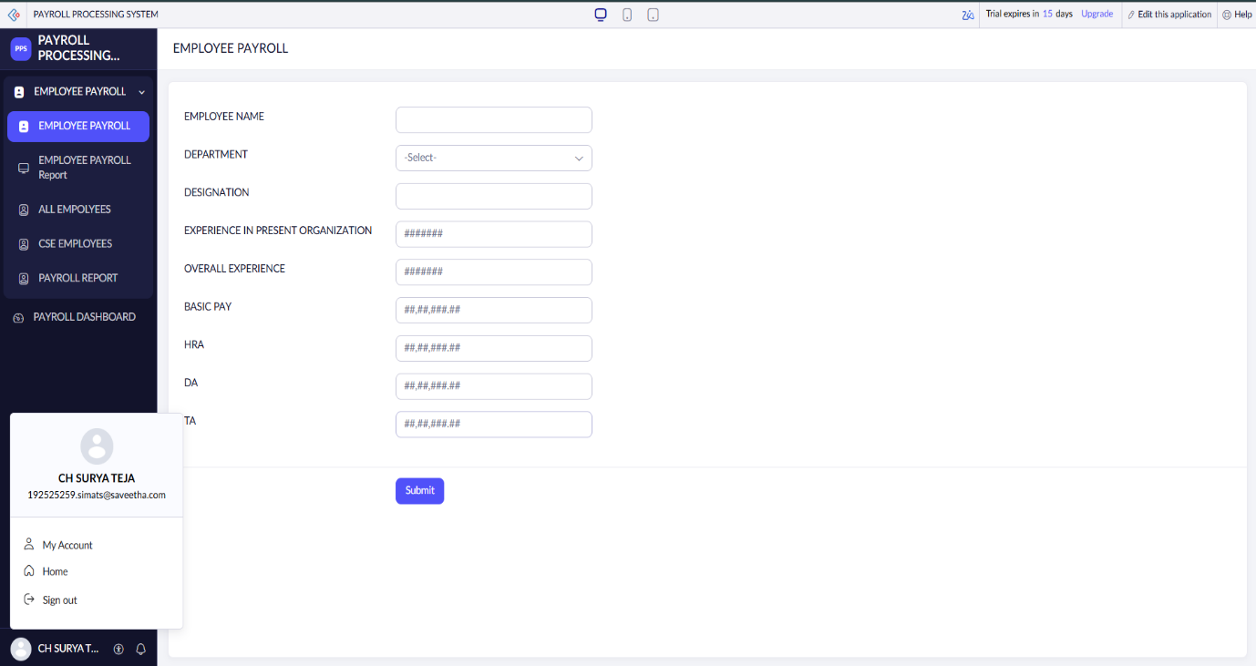
PAYROLL REPORT :
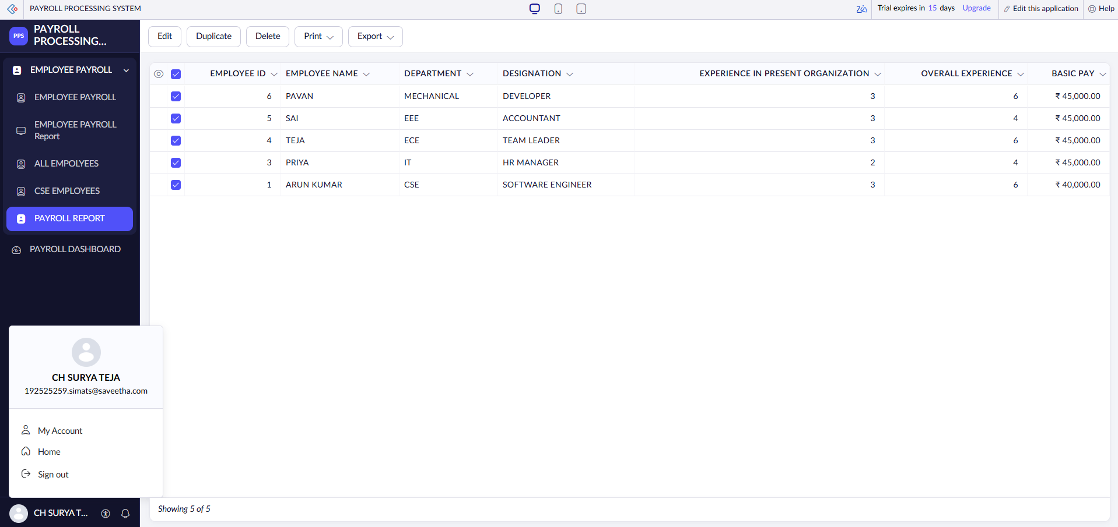

PAYROLL DASHBOARD :
